**Mechanical Engineering 2900**

**Introduction to Design in Mechanical Engineering**

**Prototype Lab – Components and Resources**

The electrical components listed below are available for you to use in your prototype project. You are required to use at least one new sensor and one new actuator. Keep in mind that you will be rewarded with more points for challenging yourself by using new components that we haven’t use in previous labs. For more information about each component, click on the component in the list below or scroll through this document.

|  |  |  |
| --- | --- | --- |
| **Sensors** |  | **Sensors** |
| [2-Axis Joystick](#Two_Axis_Joystick) |  | [Temperature Sensor](#Temperature_Sensor)  [Temperature and Humidity Sensor](#Temperature_and_Humidity_Sensor) |
| [5-Way Button](#Five_Way_Button) |  | [Tilt Ball Switch](#Tilt_Ball_Switch) |
| [Accelerometer](#Accelerometer) |  | [Ultrasonic Rangefinder](#Ultrasonic_Rangefinder) |
| [Analog Line Sensor](#Analog_Line_Sensor) |  |  |
| [Barometric Pressure/Altitude Sensor](#Barometric_PressureAltitude_Sensor) |  |  |
| [Flex (Bend) Sensor](#Flex_Sensor) |  |  |
| [Force-Sensitive Resistor](#Force_Sensitive_Resistor) |  |  |
| [Gyroscope](#Gyroscope) |  |  |
| [Hall Effect (Magnetic) Sensor](#Hall_Effect_Magnetic_Sensor) |  |  |
| [IR Distance Sensor](#IR_Distance_Sensor) |  |  |
| [IR Remote & Sensor](#IR_Remote_and_Sensor) |  |  |
| [Keypad](#Keypad) |  |  |
| [Lever Switch](#Lever_Switch) |  |  |
| [Magnetic Door Switch Set](#Magnetic_Door_Switch_Set) |  |  |
| [Microphone](#Microphone) |  |  |
| [Nintendo Touchscreen](#Nintendo_Touch_Screen) |  |  |
| [Optosensor](#Optosensor) |  |  |
| [Photoresistor](#Photoresistor) |  |  |
| [Potentiometer](#Potentiometer) |  |  |
| [Pushbutton](#Pushbutton) |  |  |
| [RedBot Mechanical Bumper](#Redbot_Mechanical_Bumper) |  |  |
| [Rotary Encoder](#Rotary_Encoder) |  |  |
| [Simple Motor and Encoder Kit](#Simple_Motor_Encoder_Kit) |  |  |

|  |  |  |
| --- | --- | --- |
| **Actuators** |  | **Actuators** |
| [10-Segment LED Bar Graph](#LED_Bar_Graph) |  |  |
| [7-Segment Clock Display](#Clock_Display) |  |  |
| [Continuous Rotation Servo Motor](#Continuous_Rotation_Servo_Motor) |  |  |
| [DC Motor](#DC_Motor) |  |  |
| [DC Motor with H-Bridge](#DC_Motor_with_HBridge) |  |  |
| [EasyDriver Stepper Motor Driver](#EasyDriver_Stepper_Motor_Driver) |  |  |
| [EL Inverter](#EL_Inverter) |  |  |
| [EL Wire](#EL_Wire) |  |  |
| [Fan](#Fan) |  |  |
| [LCD Display](#LCD_Display) |  |  |
| [LCD Display with Serial Backpack](#LCD_Display_Serial_Backpack) |  |  |
| [LED](#LED) |  |  |
| [Micro Servo Motor](#Micro_Servo_Motor) |  |  |
| [Nokia Phone Graphical LCD](#Nokia_Graphical_LCD_Display) |  |  |
| [OLED Graphical Display](#OLED_Graphical_Display) |  |  |
| [Piezo Buzzer](#Piezo_Buzzer) |  |  |
| [Relay](#Relay) |  |  |
| [RGB LED](#RGB_LED) |  |  |
| [Serial Controlled Motor Driver](#Serial_Controlled_Motor_Driver) |  |  |
| [Simple Motor and Encoder Kit](#Simple_Motor_Encoder_Kit) |  |  |
| [Solenoid](#Solenoid) |  |  |
| [Stepper Motor (with EasyDriver)](#Stepper_Motor_with_EasyDriver) |  |  |
| [Stepper Motor (with H-Bridge)](#Stepper_Motor_with_HBridge) |  |  |
| [Vibration Motor](#Vibration_Motor) |  |  |

**2-Axis Joystick**

[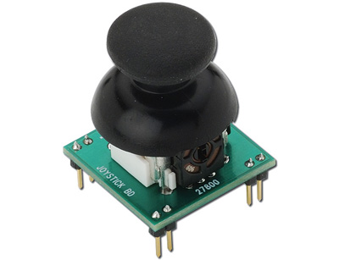](javascript:popupWindow('http://www.adafruit.com/index.php?main_page=popup_image&pID=245'))

|  |  |
| --- | --- |
| **Supplier** | Adafruit: <http://www.adafruit.com/products/245> |
| **Online Tutorial & Example Code** | This joystick consists of two potentiometers oriented at 90° to each other. One pot works in the up-down direction, and the other works in the left-right direction. Here is a tutorial about using a potentiometer:  <http://learn.adafruit.com/adafruit-arduino-lesson-8-analog-inputs/overview> |
| **Tips and Tricks:**  To wire this up, connect the **L/R+** and **U/D+** pins to **+5V**, connect any of the **GND** pins to **Ground**, and connect one of the **L/R** pins to an analog input pin (such as **A0**) and one of the **U/D** pins to another analog input pin (such as **A1**).  To get a sense for how this works, write a sketch that uses analogRead(A0); and analogRead(A1) to read the potentiometer’s x-y values, and print those values to the serial monitor. | |

**5-W****ay Button**

[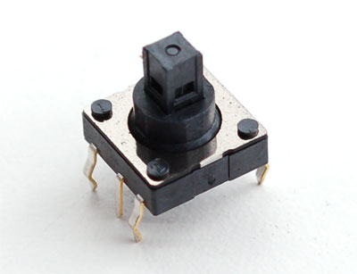](javascript:popupWindow('http://www.adafruit.com/index.php?main_page=popup_image&pID=504'))

|  |  |
| --- | --- |
| **Supplier** | Adafruit: <http://www.adafruit.com/products/504> |
| **Online Tutorial & Example Code** | This is just like our regular little buttons, except it contains five buttons (up, down, left, right, and select). The following tutorial is all about using buttons and taking digital readings:  <http://learn.adafruit.com/adafruit-arduino-lesson-6-digital-inputs/overview> |
| **Tips and Tricks:**  First, recall how the original button circuit (shown below) works. Pressing the button yields a LOW reading, and not pressing the button yields a HIGH reading.    **Arduino Input Pin**  **(ex: Digital Pin 2)**      Look at the top left diagram on this page. Note the orientation of the button (the middle pins are slightly off-center) and the pin numbers (1-6). Also note that pushing the knob “up” corresponds to direction A. Pushing the knob “left” corresponds to direction B, and so on.  Now look at the button’s schematic diagram directly above. This shows us that Pin 4 is “common,” which means that it should be connected to ground. Pushing the button in direction A connects pin 1 to Common. Pushing the button in direction B connects pin 2 to Common, and so on.  To wire this up, you will have to build five of the original button circuits. This means…   * Connect pin 4 to Ground * For each of the other pins (1, 2, 3, 5, and 6), build the following circuit:     **Arduino Input Pin**  **(ex: Digital Pin 2)**  **Button Pin  (1, 2, 3, 5, or 6)**  The Arduino Input Pin will read LOW whenever the button is pressed in the corresponding direction. | |

**Accelerometer**

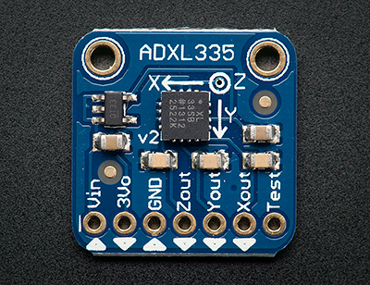

|  |  |
| --- | --- |
| **Supplier** | Adafruit: <http://www.adafruit.com/products/163> |
| **Online Tutorial & Example Code** | <http://learn.adafruit.com/adafruit-analog-accelerometer-breakouts/overview> |
| **Tips and Tricks:**  Provide the board with +5V in the Vin pin, and ground in the GND pin.  (If you want, you could provide 3.3V to the 3Vo pin instead of providing 5V to the Vin pin. The chip on the board operates at 3.3V, but there’s a regulator on the board that allows you to provide either 5V or 3.3V.)  The board is capable of measuring accelerations of up to +/- 3g.  The analog outputs are ratiometric: that means that 0g measurement output is always at half of the 3.3V output (1.65V), -3g is at 0v and 3g is at 3.3V with full scaling in between. | |

**Analog Line Sensor**

**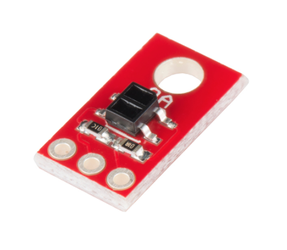**

|  |  |
| --- | --- |
| **Supplier** | Sparkfun: <https://www.sparkfun.com/products/9453> |
| **Online Tutorial & Example Code** | <http://bildr.org/2011/06/qre1113-arduino/> |
| **Tips and Tricks:** | |

**Barometric** **Pressure/Altitude Sensor**

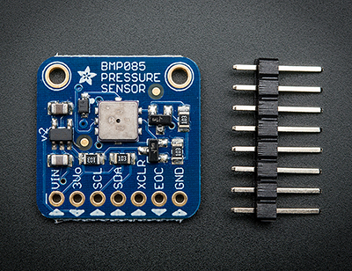

|  |  |
| --- | --- |
| **Supplier** | Adafruit: <http://www.adafruit.com/products/391> |
| **Online Tutorial & Example Code** | <http://learn.adafruit.com/bmp085> |
| **Tips and Tricks:**  This sensor uses a communication protocol called I2C (pronounced “*Eye Squared C*”). It’s kind of like serial communication, but operates differently.  To use this sensor, connect the Vin pin to 5V, GND to ground, SCL to I2C Clock (pin A5) and SDA to I2C Data (pin A4). Then download the [BMP085 Arduino library and example code for temperature, pressure and altitude calculation.](https://github.com/adafruit/Adafruit-BMP085-Library) Install the library, and load the example sketch included with the library. Immediately you'll have precision temperature, pressure and altitude data.  For help installing libraries, follow the steps in the “Installing and Importing Libraries” document on Carmen.  Note: This sensor has been discontinued by the manufacturer and [replaced with the BMP180,](http://www.adafruit.com/products/1603) which is a drop-in replacement that uses the same pin layout and code. | |

**Flex (Bend) Sensor**

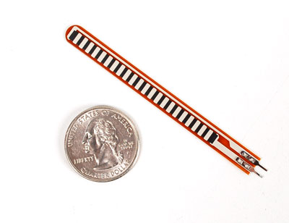 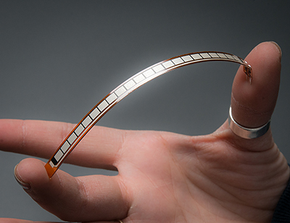

|  |  |
| --- | --- |
| **Supplier** | Adafruit, shorter one: <http://www.adafruit.com/products/1070>  Adafruit, longer one:  <http://www.adafruit.com/products/182> |
| **Online Tutorial & Example Code** | These are very similar to Force Sensitive Resistors, so this tutorial will help get you started:  <http://learn.adafruit.com/force-sensitive-resistor-fsr> |
| **Tips and Tricks:**  This sensor can detect bending in one direction. They were popularized by being used in the Nintendo PowerGlove as a gaming interface.  The resistance between the two leads increases when the sensor is flexed.  The bottom part of the sensor (where the metal pins are crimped on) is very delicate so make sure to have strain relief - such as clamping or taping that part so as not to rip out the contacts! Also, be careful not to bend the sensor so much that it plastically deforms. Only use small-to-medium deformations. Be gentle.  A wiring diagram is shown on the next page.  To use this sensor, use the following wiring diagram:  5V  68K Ω  Arduino  Analog Input Pin  (ex: Pin A0)  Sensor  Note: Changing the value of the resistor will change the sensitivity of the readings.  To get a sense for how this sensor behaves, write a sketch that uses analogRead(A0); and print those values to the serial monitor. | |

**Force-Sensitive Resis****tor**

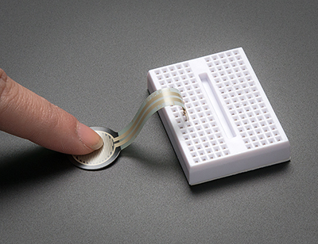

|  |  |
| --- | --- |
| **Supplier** | Adafruit: <http://www.adafruit.com/products/166> |
| **Online Tutorial & Example Code** | <http://learn.adafruit.com/force-sensitive-resistor-fsr> |
| **Tips and Tricks:**  These sensors allow you to detect physical pressure, squeezing and weight.  The resistance between the two leads decreases when the sensor is flexed. These sensors are fairly low cost but rarely accurate. Their performance can vary from sensor to sensor by about 10%. So, although force-sensitive resistors can detect force, they're a bad choice for detecting exactly how much force is being applied.  The bottom part of the sensor (where the metal pins are crimped on) is very delicate so make sure to have strain relief - such as clamping or taping that part so as not to rip out the contacts! Be gentle.  A wiring diagram is shown on the next page.  To use this sensor, use the following wiring diagram:  5V  10K Ω  Arduino  Analog Input Pin  (ex: Pin A0)  Sensor  Note: Changing the value of the resistor will change the sensitivity of the readings.  To get a sense for how this sensor behaves, write a sketch that uses analogRead(A0); and print those values to the serial monitor. | |

**Gyrosc****ope**

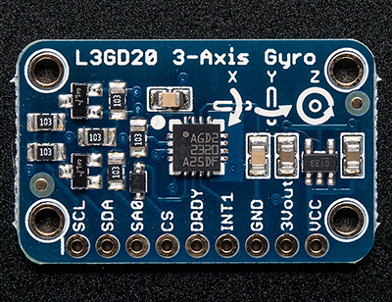

|  |  |
| --- | --- |
| **Supplier** | Adafruit: <http://www.adafruit.com/products/1032> |
| **Online Tutorial & Example Code** | <http://learn.adafruit.com/adafruit-triple-axis-gyro-breakout/overview> |
| **Tips and Tricks:**  A gyroscope can sense twisting and turning motions (as opposed to linear movement). Often paired with an accelerometer, you can use these to do 3D motion capture and inertial measurement (that is - you can tell how an object is moving, and calculate position and orientation changes!).  As these sensors become more popular and easier to manufacture, the prices for them have dropped significantly. This one costs about $25. Only a decade ago, it would have cost hundreds of dollars.  This sensor uses a communication protocol called I2C (pronounced “*Eye Squared C*”). It’s kind of like serial communication, but operates differently.  To use this sensor, connect SDA to your Arduino I2C data pin (pin A4), SCL to I2C clock (pin A5), GND to ground, and Vin to 3.3V or 5V. [Then install and import this Arduino library, which will print out the XYZ sensor data to the serial terminal.](https://github.com/adafruit/Adafruit_L3GD20) The library also supports SPI (another type of communication protocol) on any 4 digital I/O pins (in case you prefer SPI for some reason). Upload the example sketch, and open up the serial monitor to view real-time gyroscope data.  For help installing libraries, follow the steps in the “Installing and Importing Libraries” document on Carmen. | |

**Hall Effec****t (Magnetic) Sensor**

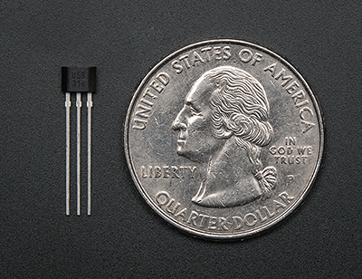

|  |  |
| --- | --- |
| **Supplier** | Adafruit: <http://www.adafruit.com/products/158> |
| **Online Tutorial & Example Code** | <http://www.hobbytronics.co.uk/arduino-tutorial11-hall-effect> |
| **Tips and Tricks:**  Hall effect sensors detect whether a magnet is near. This is a digital sensor – it will only tell you “yes, there’s a magnetic field” or “no, there’s not.” It will not tell you how strong a magnetic field is. These are great for non-contact/waterproof types of switches, position sensors, and rotary/shaft encoders.  To wire this up, connect 5V to pin 1 (all the way to the left), ground to pin 2 (middle) and then a 10K resistor from pin 3 to 5V. Also connect an Arduino digital pin directly to pin 3.  When the south pole of a magnet is near the front of the sensor, pin 3 will be LOW (0V). Otherwise it will stay HIGH (5V). Nothing occurs if a magnet's north pole is nearby.  It works just like our regular buttons, except that “pressing the button” requires that you move the south pole of a magnet close to the sensor. | |

**IR Distance** **Sensor**

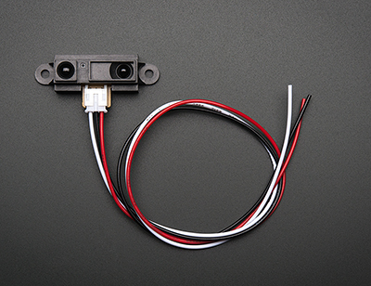

|  |  |
| --- | --- |
| **Supplier** | Adafruit: <http://www.adafruit.com/products/164> |
| **Online Tutorial & Example Code** | <http://bildr.org/2011/03/various-proximity-sensors-arduino/> |
| **Tips and Tricks:**  This distance sensor is great for measuring short distances (10 cm – 80 cm). It is very precise and works by bouncing infrared (IR) light off objects to determine how far away they are. For measuring distances over 1 meter, we suggest using an Ultrasonic Rangefinder.  To wire this up, connect the black wire to ground, red wire to 5V, and white wire to one of the Analog In pins (for example, pin A0). The analog voltage will range from 3V when an object is only 4" (10 cm) away and 0.4V when the object is 32" (80 cm) away.  To get a sense for how this sensor behaves, write a sketch that uses analogRead(A0); and print those values to the serial monitor. | |

**IR Remo****te and Sensor**

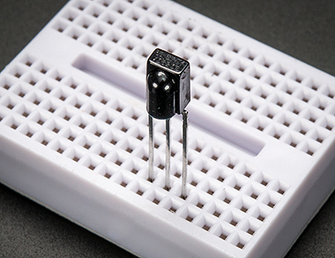 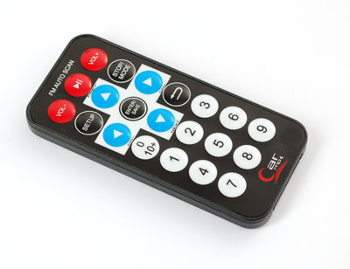

|  |  |
| --- | --- |
| **Supplier** | Adafruit, remote:  <http://www.adafruit.com/products/389>  Adafruit, sensor:  <http://www.adafruit.com/products/157> |
| **Online Tutorial & Example Code** | Example code and libraries for using this specific remote and sensor: <https://github.com/adafruit/Adafruit-NEC-remote-control-library>  Tutorial for figuring out how to use any remote control: <http://learn.adafruit.com/ir-sensor/overview> |
| **Tips and Tricks:**  Remotes work by sending quick pulses of infrared (IR) light, and the sensor simply detects whether or not it is detecting IR light.  To wire this up, connect pin 3 (all the way to the right) to 5V, pin 2 (middle) to ground and pin 1 (left) to an Arduino digital pin (Arduino pin 4 if you use the example code).  Now, download and install the library and run the example code that comes with the library to get started.  For help installing libraries, follow the steps in the “Installing and Importing Libraries” document on Carmen. | |

**Keypad**

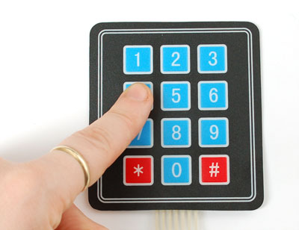

|  |  |
| --- | --- |
| **Supplier** | Adafruit: <http://www.adafruit.com/products/419> |
| **Online Tutorial & Example Code** | <http://www.arduino.cc/playground/Code/Keypad> |
| **Tips and Tricks:**  Use the example code from the link above, but change the initialization code to this:  const byte ROWS = 4; //four rows  const byte COLS = 3; //three columns  char keys[ROWS][COLS] = {  {'1','2','3'},  {'4','5','6'},  {'7','8','9'},  {'\*','0','#'}  };  byte rowPins[ROWS] = {8, 7, 6, 5}; //connect to the row pinouts of the keypad  byte colPins[COLS] = {4, 3, 2}; //connect to the column pinouts of the keypad  Keypad keypad = Keypad( makeKeymap(keys), rowPins, colPins, ROWS, COLS );  This will swap the \* and # keys and also let you connect to the Arduino to match this image: <http://www.adafruit.com/images/large/membranekeypad34arduino_LRG.jpg>  For help installing libraries, follow the steps in the “Installing and Importing Libraries” document on Carmen. | |

**Lever** **Switch (SPDT with Lever)**

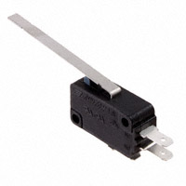

|  |  |
| --- | --- |
| **Supplier** | Digikey: <http://www.digikey.com/product-search/en?wt.z_header=search_go&lang=en&keywords=EG4527-ND&x=0&y=0&cur=USD> |
| **Online Tutorial & Example Code** | <http://learn.adafruit.com/adafruit-arduino-lesson-6-digital-inputs> |
| **Tips and Tricks:**  This switch has a click-y lever and three leads. The bottom lead is “common” and should be connected to ground. The two leads sticking out the side have the label “NC” or “NO” next to them. NC means Normally Closed, and NO means Normally Open.  The NC lead is normally connected to the common pin, but disconnects while you press the lever. The NO lead is normally disconnected from ground, but connects while you press the lever.  Use this just like normal pushbuttons, and choose whether you want to use the NC or NO pin based on your needs. Here’s the button circuit:  E:\Users\MichaelNeal\Documents\_ME 2900 Lab Documents - AU13\Lab 2\ButtonCircuit.png | |

**Magnetic Doo****r Switch Set**

**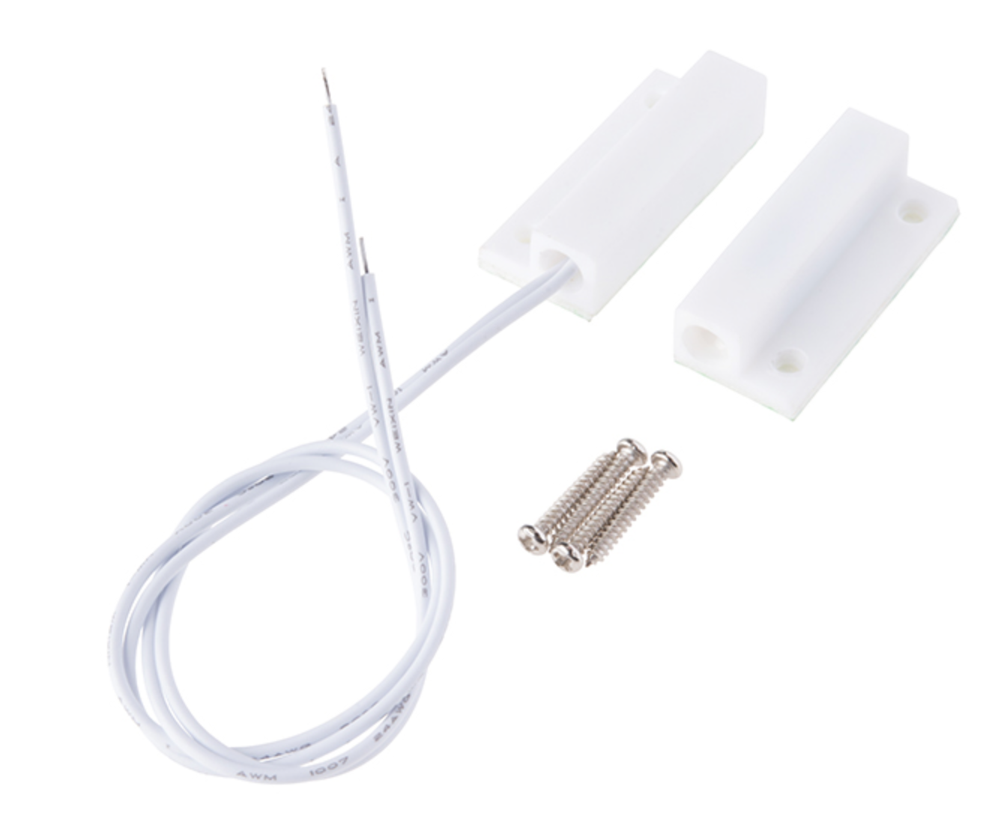**

|  |  |
| --- | --- |
| **Supplier** | Sparkfun: <https://www.sparkfun.com/products/13247> |
| **Online Tutorial & Example Code** | <https://www.sparkfun.com/videos#all/RZwMlnuBW_M/82> |
| **Tips and Tricks:**  These types of switches are primarily used in home security systems. One half of the assembly set on a window or door frame and the other attached to the window or door itself. When the switch set is separated from each other the contact is broken and triggers an alarm.  When each magnet piece comes within 20mm of each other they complete the circuit with the internal reed switches. Each Magnetic Door Switch set can accept a max voltage of up to 100V at 500mA. Additionally each set is housed in durable ABS plastic and, with the included screws, can easily mount to most surfaces. | |

**Mi****crophone**

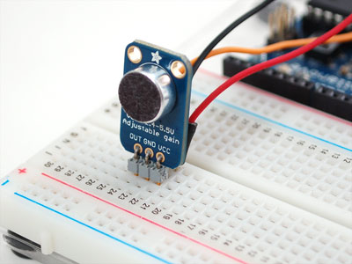

|  |  |
| --- | --- |
| **Supplier** | Adafruit: <http://www.adafruit.com/products/1063> |
| **Online Tutorial & Example Code** | Measure sound levels:  <http://learn.adafruit.com/adafruit-microphone-amplifier-breakout/overview>  More tutorials involving this sensor: <http://www.adafruit.com/products/1063#Learn> |
| **Tips and Tricks:**    This sensor works great if you want to detect changes in volume. It can also be used to detect sound frequencies if you use the FFT library as discussed here: <http://learn.adafruit.com/adafruit-microphone-amplifier-breakout/overview> | |

**Nintendo Touch Screen**

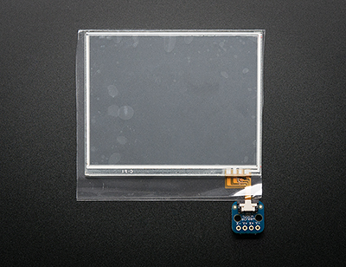

|  |  |
| --- | --- |
| **Supplier** | Adafruit, Touch Screen:  <http://www.adafruit.com/products/333>  Adafruit, Connector:  <http://www.adafruit.com/products/334> |
| **Online Tutorial & Example Code** | <https://github.com/adafruit/Touch-Screen-Library> |
| **Tips and Tricks:**  This is the same touch screen that was used on the Nintendo DS Lite. To use it, carefully attach the little connector to the ribbon, and plug the connector board into your breadboard. Upload the example code and install all necessary libraries.  These can be used to detect pressure and location when you touch the screen with your finger or a stylus.  You can put it over a paper overlay for a touch control panel or attach it to an LCD to create your own touch-activated display. | |

**Opto****sensor**

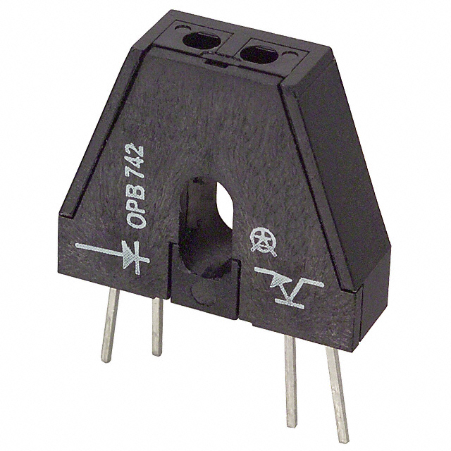

|  |  |
| --- | --- |
| **Supplier** | Digikey: <http://www.digikey.com/product-detail/en/OPB742/365-1014-ND/374792> |
| **Online Tutorial & Example Code** | None |
| **Tips and Tricks:**  This sensor actually consists of two components – an infrared (IR) LED and a phototransistor. When a reflective object is held about 1/8” above the holes, infrared light reflects into the right hole, activating the base of the phototransistor. This allows current to flow in through the collector and out of the emitter of the transistor.  Here is a wiring diagram for this sensor: | |

**Photor****esistor**

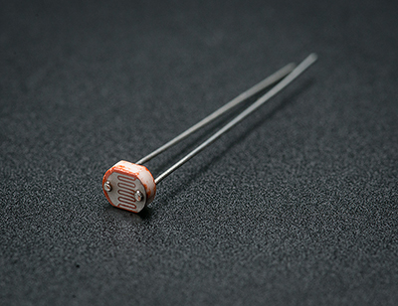

|  |  |
| --- | --- |
| **Supplier** | Adafruit: <http://www.adafruit.com/products/161> |
| **Online Tutorial & Example Code** | <http://learn.adafruit.com/photocells> |
| **Tips and Tricks:**  This sensor can be used to detect varying amounts of light. As the squiggly face is exposed to more light, the resistance goes down. When its light, the resistance is about 5-10KΩ, and when dark it goes up to 200KΩ.  To use, connect one side of the photo cell (either one, its symmetric) to power (for example 5V) and the other side to your microcontroller's analog input pin. Then connect a 10K resistor from that analog pin to ground (this is called a pull-down resistor). The voltage on the pin will be 2.5V or higher when its light out and near ground when its dark. | |

**Potentiometer**

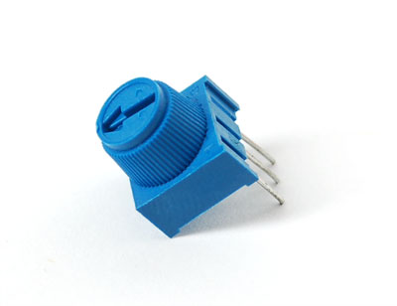

|  |  |
| --- | --- |
| **Supplier** | Adafruit: <http://www.adafruit.com/products/356> |
| **Online Tutorial & Example Code** | <http://learn.adafruit.com/adafruit-arduino-lesson-8-analog-inputs> |
| **Tips and Tricks:**  This is a 10KΩ potentiometer. This means that the maximum resistance between the middle and an outer pin is 10KΩ, and the minimum resistance is zero. The resistance between the middle and outer pins changes as you turn the knob.  To measure the knob’s position, connect either the first or third pin to 5V and the other to ground. Connect the middle pin to an Analog In pin on the Arduino.  To use this as a simple variable resistor, put it in series with something like an LED and only use the middle and one of the outer pins of the pot. Treat it like a plain old resistor with two leads, but the resistance between those two leads will change as you turn the knob. | |

**Pushbutton (AKA Tactile Switch)**

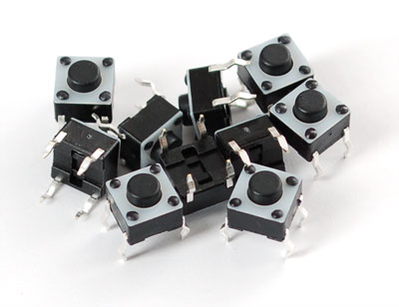

|  |  |
| --- | --- |
| **Supplier** | Adafruit: <http://www.adafruit.com/products/367> |
| **Online Tutorial & Example Code** | <http://learn.adafruit.com/adafruit-arduino-lesson-6-digital-inputs> |
| **Tips and Tricks:**  Here is a typical button circuit:  E:\Users\MichaelNeal\Documents\_ME 2900 Lab Documents - AU13\Lab 2\ButtonCircuit.png  This circuit uses a resistor called a “pull-up resistor.” That’s because the resistor pulls pin 2 up to 5V when the button is not pressed. Alternatively, you could swap the location of the button and resistor, and that would give you a “pull-down resistor.” It’s called “pull-down” because pin 2 is pulled down to ground when the button is not pressed. | |

**RedBot** **Mechanical Bumper**

**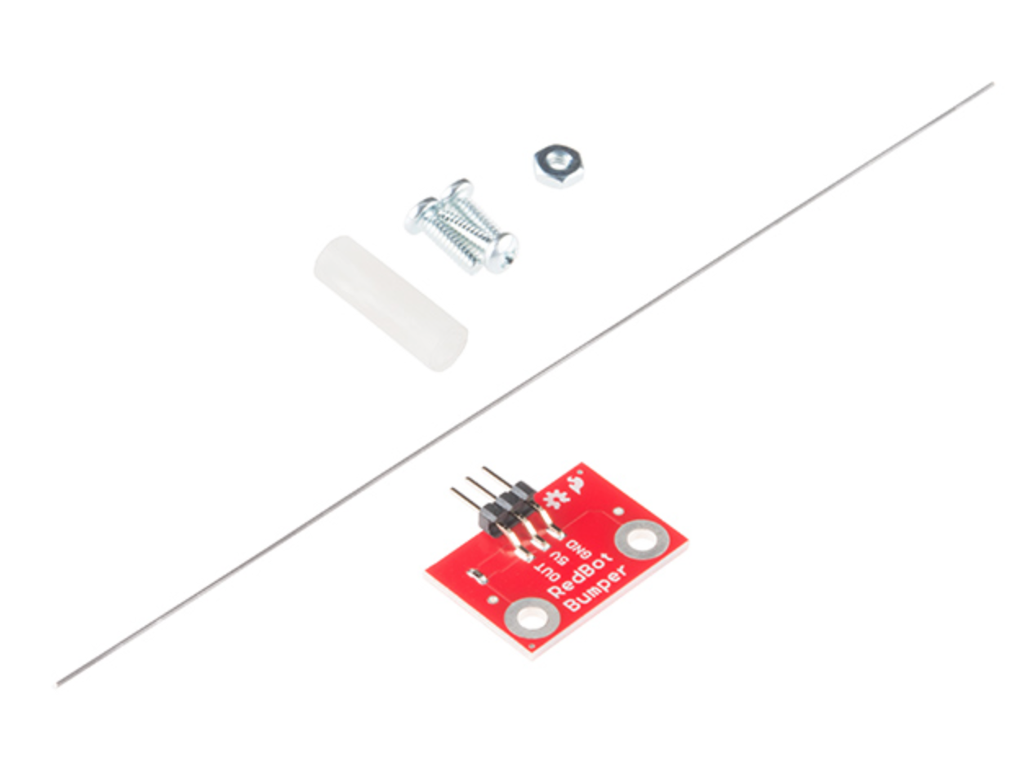**

|  |  |
| --- | --- |
| **Supplier** | Sparkfun: <https://www.sparkfun.com/products/11999> |
| **Online Tutorials & Example Code** | <https://learn.sparkfun.com/tutorials/redbot-assembly-guide-rev-02/redbot-sensor---mechanical-bumpers?_ga=1.157844986.1123859691.1441058319>  <https://www.sparkfun.com/videos#all/70yBAWThTc4/160> |
| **Tips and Tricks:** | |

**Rotary Encoder**

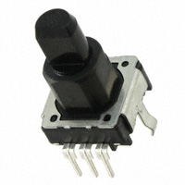

|  |  |
| --- | --- |
| **Supplier** | Digikey: <http://www.digikey.com/product-detail/en/EVE-KE2F2024B/P12335-ND/593498> |
| **Online Tutorial & Example Code** | Tutorial of using a similar encoder with a Trinket, which is like a tiny Arduino: <http://learn.adafruit.com/trinket-usb-volume-knob/overview>  Tutorial of using any encoder with an Arduino:  <http://www.hobbytronics.co.uk/arduino-tutorial6-rotary-encoder> |
| **Tips and Tricks:**  Rotary encoders are useful as rotation sensors and look similar to potentiometers. However, they are not like potentiometers at all, so it's important to realize the difference!  These rotary encoders rotate all the way around continuously, and rotations are divided up into 24 segments. Each 1/24th of a rotation clockwise or counter-clockwise causes two switches inside the encoder to open and close.  There is no way to know what the current “position” of the knob is - instead you would use a microcontroller to count how many segments left or right the knob has been turned. If you need to detect angular position, a potentiometer might be a better choice, but the advantage of an encoder is that it can rotate all the way around.  To use an encoder, follow one of the tutorials listed above. | |

**Simpl****e Motor and Encoder Kit**

**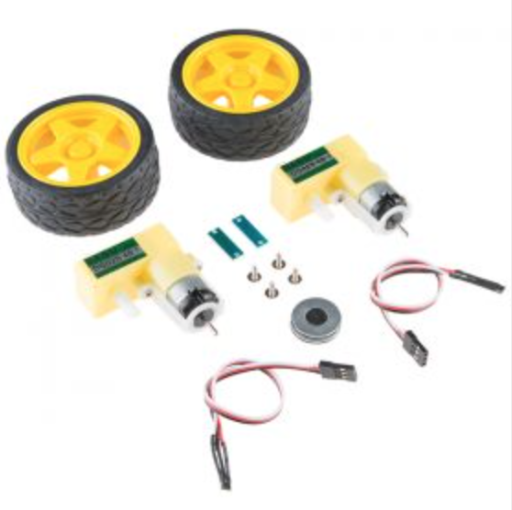**

|  |  |
| --- | --- |
| **Supplier** | Dagu: <https://abra-electronics.com/robotics-embedded-electronics/robot-kits-en/rs034-hobby-motor-and-encoder-kit.html?sl=en> |
| **Online Tutorial & Example Code** | <https://learn.sparkfun.com/tutorials/redbot-assembly-guide-rev-02/all> |
| **Tips and Tricks:** | |

**Tempera****ture Sensor**

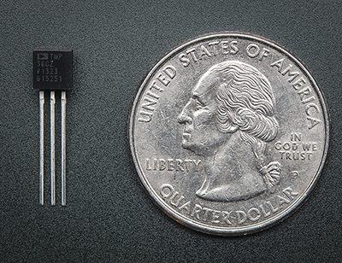

|  |  |
| --- | --- |
| **Supplier** | Adafruit: <http://www.adafruit.com/products/165> |
| **Online Tutorial & Example Code** | <http://learn.adafruit.com/tmp36-temperature-sensor> |
| **Tips and Tricks:**  This wide range, low power temperature sensor outputs an analog voltage that is proportional to the ambient temperature.  To wire this up, connect pin 1 (left) to power (between 2.7 and 5.5V), pin 3 (right) to ground, and pin 2 to an Arduino Analog In pin. The voltage out is 0V at -50°C and 1.75V at 125°C. You can easily calculate the temperature from the voltage in millivolts using this equation:  **Temp in °C = 100\*(reading in V) – 50**  Note that the “front” of the sensor is the flat side. | |

**Temperature and Humidity Sensor**

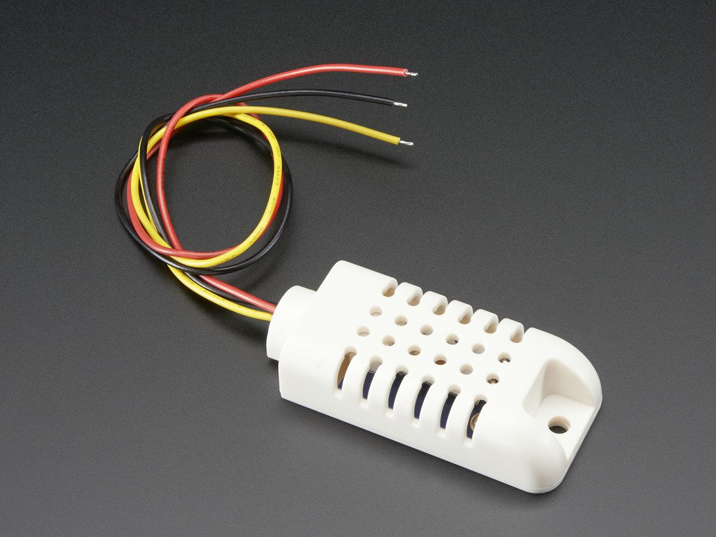

|  |  |
| --- | --- |
| **Supplier** | Adafruit: <https://www.adafruit.com/products/393> |
| **Online Tutorial & Example Code** | <https://learn.adafruit.com/dht> |

**Tilt B****all Switch**

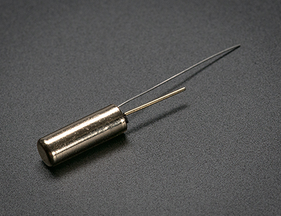

|  |  |
| --- | --- |
| **Supplier** | Adafruit: <http://www.adafruit.com/products/173> |
| **Online Tutorial & Example Code** | <http://learn.adafruit.com/tilt-sensor> |
| **Tips and Tricks:**  The "poor man's" accelerometer! Tilt sensors are switches that can detect basic motion/orientation. The metal tube has a little metal ball that rolls around in it. When it is positioned upright, the ball rolls onto the contacts sticking out of end and connects them together.  Use this to detect whenever something is bumped, shaken, or flipped around. | |

**Ultras****onic Rangefinder**

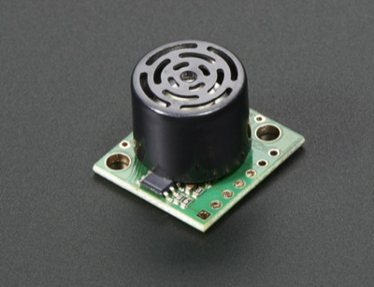 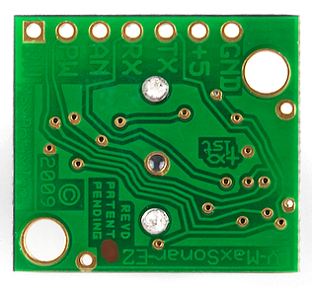

|  |  |
| --- | --- |
| **Supplier** | Adafruit: <https://www.adafruit.com/products/172> |
| **Online Tutorial & Example Code** | None |
| **Tips and Tricks:**  This rangefinder can be used to measure distances between 6 inches and 254 inches (up to 21 feet!) with 1-inch precision.  To wire this up, connect 5V and Ground to the sensor, and connect the “AN” port to an Arduino Analog In pin. The voltage of the AN pin increases as the measured distance increases. It follows this formula:  **Distance = 102.4\*(Voltage on “AN” pin)** | |

**10-Seg****ment LED Bar Graph**

|  |  |
| --- | --- |
| **Supplier** | Sparkfun: <https://www.sparkfun.com/products/9935> |
| **Online Tutorial & Example Code** | <https://www.youtube.com/watch?v=v8NcdahFjHM>  <https://learn.sparkfun.com/tutorials/dotbar-display-driver-hookup-guide?_ga=1.166374910.1123859691.1441058319> |
| **Tips and Tricks:**  The pinout on these bar graphs may vary from what is listed on the datasheet. Rotating the device 180 degrees will correct the change making pin 11 the first pin in line. We have contacted our supplier to correct this mistake in the future. | |

**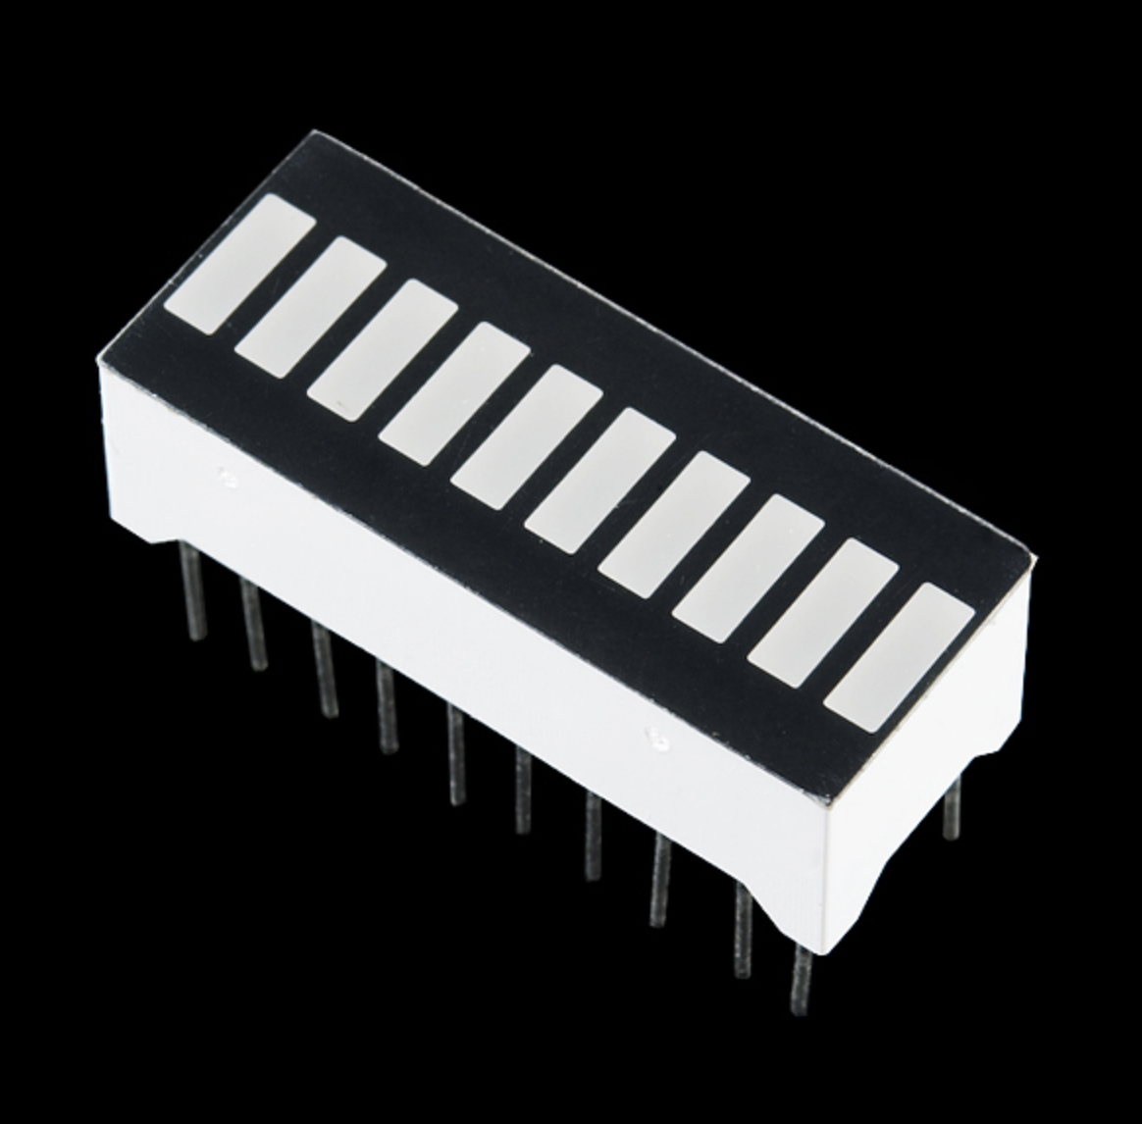**

**7-Segme****nt Clock Display**

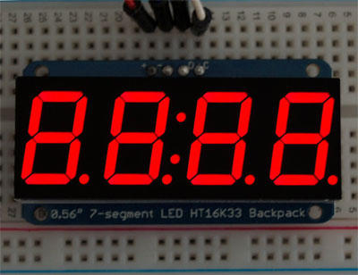

|  |  |
| --- | --- |
| **Supplier** | Adafruit: <http://www.adafruit.com/products/878> |
| **Online Tutorial & Example Code** | <http://learn.adafruit.com/adafruit-led-backpack/0-dot-56-seven-segment-backpack> |
| **Tips and Tricks:**  Follow the tutorial to get this up and running. It uses a communication protocol called I2C (pronounced “*Eye Squared C*”). It’s kind of like serial communication, but operates differently.  Wire this up according to the tutorial, and then download this library: <https://github.com/adafruit/Adafruit-LED-Backpack-Library>  The link above comes with example code for this specific component.  For more information about incorporating the library into your sketch, read the “Installing and Importing Libraries” document on Carmen.  One important tip – whenever you want to update the display, write “matrix.writeDisplay();” in your code. Just because you tell it to display the number “5,” it won’t automatically display it. You have to insert “matrix.writeDisplay();” in order to update the display and show the number 5. You’ll see this in the example sketch. | |

**Continuo****us Rotation Servo Motor**

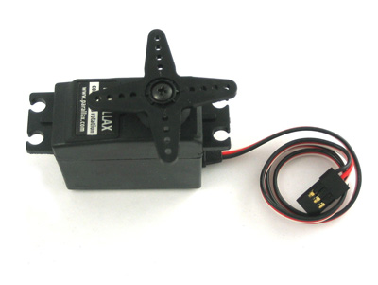

|  |  |
| --- | --- |
| **Supplier** | Adafruit: <http://www.adafruit.com/products/154> |
| **Online Tutorial & Example Code** | Regular Servo Example: <http://learn.adafruit.com/adafruit-arduino-lesson-14-servo-motors/overview> |
| **Tips and Tricks:**  This servo rotates continuously forward or backwards instead of moving to a position. You can use any servo code, hardware or library to control these servos. Use this motor if you want to be able to control speed and also have a lot of torque.  To control with an Arduino, connect the white control wire to pin 9 or 10 and use the Servo Library (click Sketch 🡪 Import Library 🡪 Servo).  Telling the servo to move to position "90" (1.5ms pulse) is stop, "180" (2ms pulse) is full speed forward, "0" (1ms pulse) is full speed backwards.  You may have to calibrate the servo. To do this, tell the servo to go to position 0 (stop), and use a screwdriver to adjust the potentiometer in the recessed hole until the servo actually stops moving. | |

**DC Moto****r**

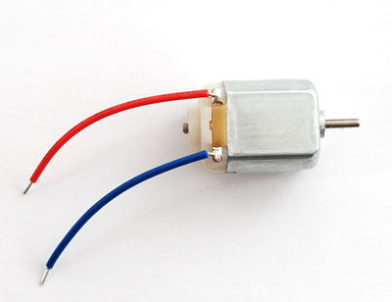

|  |  |
| --- | --- |
| **Supplier** | Adafruit: <http://www.adafruit.com/products/711> |
| **Online Tutorial & Example Code** | <http://learn.adafruit.com/adafruit-arduino-lesson-13-dc-motors> |
| **Tips and Tricks:**  These are great for high speed, low torque applications.  If you need absolute control over speed and position, use a stepper motor instead. If you need to control position and only need the shaft to rotate up to 180 degrees, use a servo motor. We also have *continuous rotation* servo motors (basically a DC motor that’s slower and has more torque). | |

**DC Mot****or with H-Bridge**

 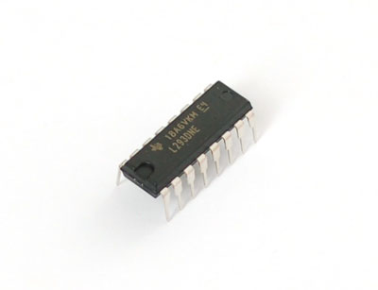

|  |  |
| --- | --- |
| **Supplier** | Adafruit, DC Motor: <http://www.adafruit.com/products/711>  Adafruit, H-Bridge:  <http://www.adafruit.com/products/807> |
| **Online Tutorial & Example Code** | <http://learn.adafruit.com/adafruit-arduino-lesson-15-dc-motor-reversing> |
| **Tips and Tricks:**  Use an H-Bridge with your DC motor if you want to provide an external power supply for your DC motor to give it more torque. H-Bridges can also allow you to control two DC motors at the same time, and also easily change the motor’s direction. Check out the tutorial for details. | |

**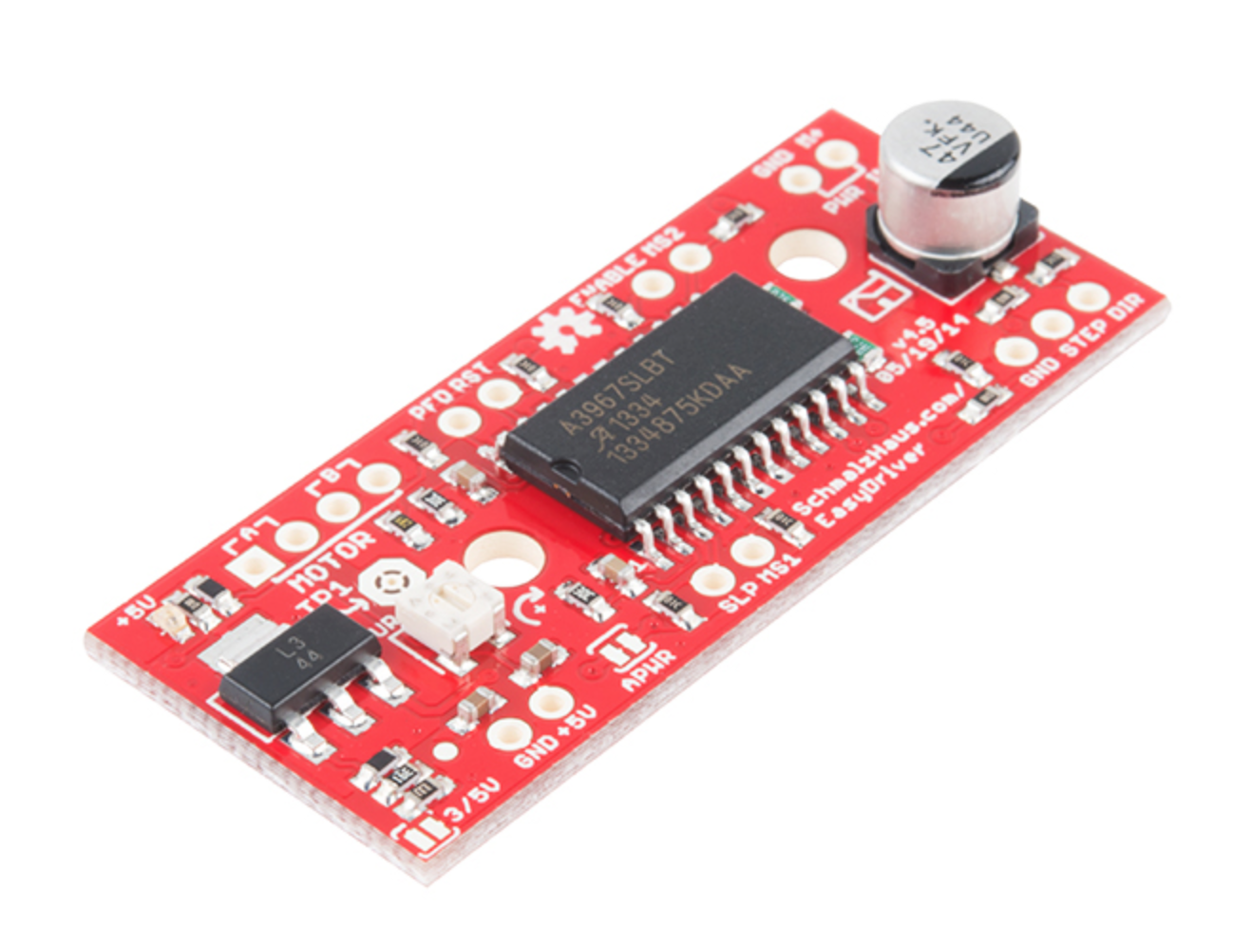EasyDriver Stepper Moto****r Driver**

|  |  |
| --- | --- |
| **Supplier** | Sparkfun: <https://www.sparkfun.com/products/12779> |
| **Online Tutorial & Example Code** | <http://bildr.org/2011/06/easydriver/>  <https://learn.sparkfun.com/tutorials/easy-driver-hook-up-guide?_ga=1.220891480.1123859691.1441058319> |
| **Tips and Tricks:** | |

**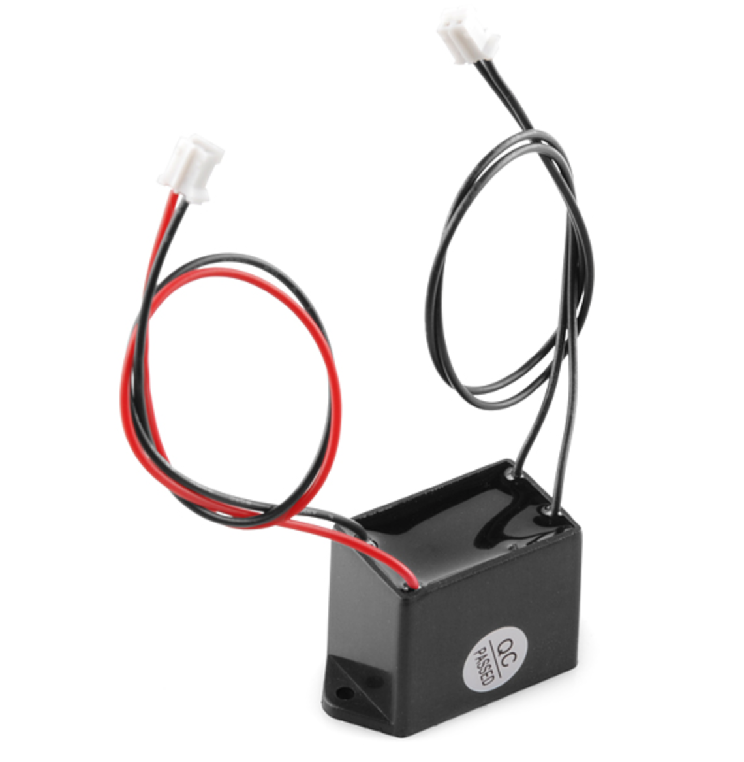EL Inve****rter**

|  |  |
| --- | --- |
| **Supplier** | Sparkfun: <https://www.sparkfun.com/products/10201> |
| **Online Tutorial & Example Code** | <https://www.youtube.com/watch?t=6&v=D4ZcCuBsfuM> |
| **Tips and Tricks:** | |

**EL (Ele****ctroluminescent) Wire**

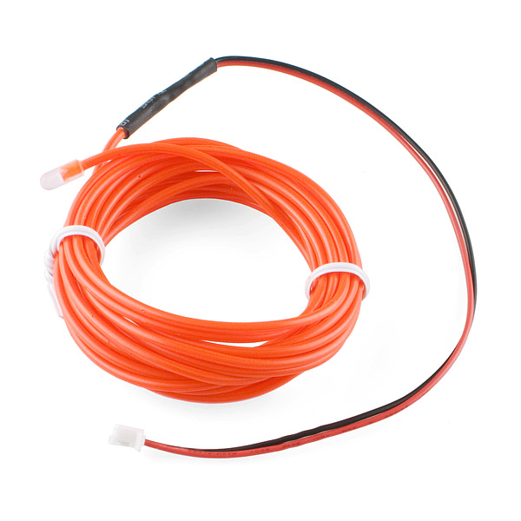 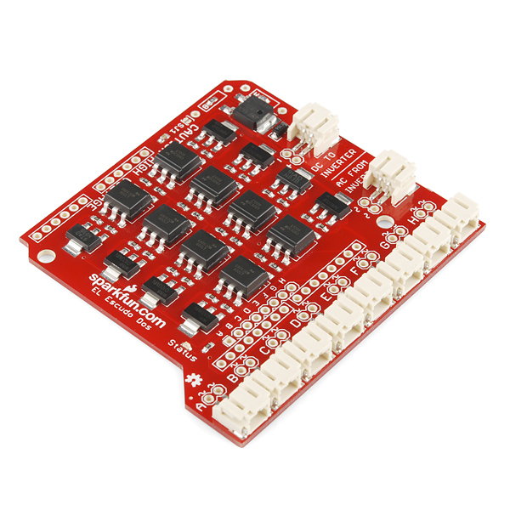

|  |  |
| --- | --- |
| **Supplier** | SparkFun, EL Wire: <https://www.sparkfun.com/products/10191>  SparkFun, EL Escudo Dos:  <https://www.sparkfun.com/products/10878> |
| **Online Tutorial & Example Code** | <https://www.sparkfun.com/tutorials/353> |
| **Tips and Tricks:**  EL wire looks like a sort of LED “wire,” but it works quite differently than LEDs. For details about the physics behind EL wire, check out this page: <http://en.wikipedia.org/wiki/Electroluminescent_wire>  Using EL wire requires a driver board, such as the EL Escudo Dos (top right of this page). The EL Escudo Dos is a SparkFun product made specifically for the type of EL wire we have. The EL Escudo Dos works as a “middleman” between the Arduino and the EL wire. The Arduino sends a signal to the EL Escudo Dos, and the EL Escudo Dos figures out how to light up the EL wire based on the signal from the Arduino. | |

**Fa****n**

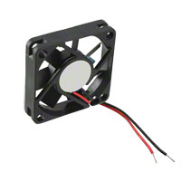

|  |  |
| --- | --- |
| **Supplier** | <http://www.digikey.com/product-detail/en/sunon-fans/ME45100V1-000U-A99/259-1577-ND/2757794> |

**LCD Di****splay**

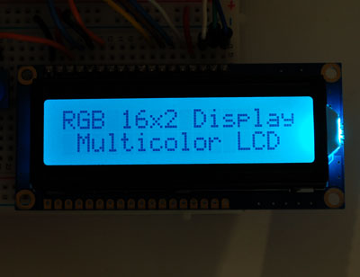

|  |  |
| --- | --- |
| **Supplier** | Adafruit: <http://www.adafruit.com/products/398> |
| **Online Tutorial & Example Code** | <http://learn.adafruit.com/character-lcds/rgb-backlit-lcds> |
| **Tips and Tricks:**  This LCD display can display characters and has a size of 16 x 2 characters.  The cool thing about our LCD displays is that you can change the color of the backlight! Use PWM signals to change the backlight’s color to anything you can imagine.  To use it, click on the tutorial link above and **wire it exactly as shown in the picture**. The wiring picture is also shown below:  rgblcdtest_t.jpg  Continued  on next page  After wiring, upload the example code and experiment with different backlight colors and write whatever messages you want.  Since this display requires a lot of pins on your Arduino, we also have Serial-enabled displays that only require three wires – 5V power, GND, and the TX pin. The coding is only slightly more difficult. If you are interested in using the serial enabled display, check out the next page below.  If you want to be able to display graphics (pictures or symbols), check out the Nokia Graphical LCD Display and the OLED Graphical Display. These are more difficult to code but allow you to display pictures in black and white. | |

**LCD Display with Serial Backpack**

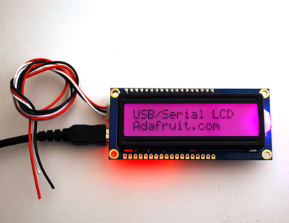

|  |  |
| --- | --- |
| **Supplier** | Adafruit: <http://www.adafruit.com/products/782> |
| **Online Tutorial & Example Code** | <http://learn.adafruit.com/usb-plus-serial-backpack/testing-with-ttl-serial> |
| **Tips and Tricks:**  This LCD display can display characters and has a size of 16 x 2 characters. The cool thing about our LCD displays is that you can change the color of the backlight! Use PWM signals to change the backlight’s color to anything you can imagine.  This particular LCD Display only requires three wires – 5V Power, GND, and a TX pin. There’s a microcontroller on the back of the display that receives data from the Arduino via serial communication and controls the display based on the commands received from the Arduino.  Check out the example code by clicking on the link above, then [click here to read about all the commands you can use to control the display.](http://learn.adafruit.com/usb-plus-serial-backpack/command-reference)  If you want to be able to display graphics (pictures or symbols), check out the Nokia Graphical LCD Display and the OLED Graphical Display. These are more difficult to code but allow you to display pictures in black and white. | |

**Light Emittin****g Diode (LED)**

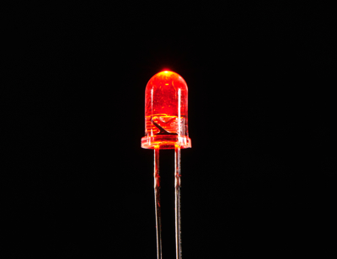

|  |  |
| --- | --- |
| **Supplier** | Adafruit: <http://www.adafruit.com/products/297> |
| **Online Tutorial & Example Code** | <http://learn.adafruit.com/all-about-leds> |
| **Tips and Tricks:**  Always use a resistor in series with an LED so it doesn’t burn out. A safe bet is to start with a 1KΩ resistor. If you need it to be more bright, you can decrease to a lower resistance. | |

**Micr****o Servo Motor**

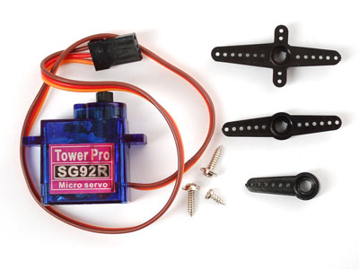

|  |  |
| --- | --- |
| **Supplier** | Adafruit: <http://www.adafruit.com/products/169> |
| **Online Tutorial & Example Code** | <http://learn.adafruit.com/adafruit-arduino-lesson-14-servo-motors> |
| **Tips and Tricks:**  Servo motors can move their shaft to a precise position between 0 and 180 degrees. Servo motors are easy to use with the Servo library. Check out the tutorial for wiring diagrams, example code, and example projects with the servo. | |

**Nokia Phone Grap****hical LCD Display**

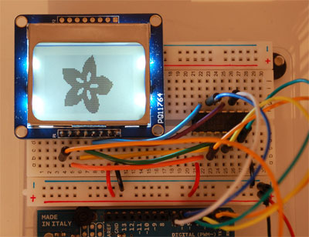

|  |  |
| --- | --- |
| **Supplier** | Adafruit: <http://www.adafruit.com/products/338> |
| **Online Tutorial & Example Code** | <http://learn.adafruit.com/nokia-5110-3310-monochrome-lcd> |
| **Tips and Tricks:**  This is the display that used to be in old Nokia cell phones. Maybe you remember…the ones that looked like this:  http://media-cache-ak0.pinimg.com/originals/04/4a/e4/044ae4cf28a238a3a7b182d591c796cd.jpg  Anyway, these are great for displaying black and white graphics and text. Check out the tutorial for detailed wiring and usage instructions. One tip – you have to write the following line of code every time you want to update what is shown on the display:  display.display();  Otherwise, the code will just be telling it, “get ready to display \_\_\_”. Use display.display(); to make sure that actually gets displayed.  You will have to install a couple of libraries to use this. Check out the “Installing and Importing Libraries” document on Carmen. | |

**OLED Graphical** **Display**

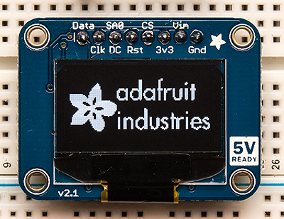

|  |  |
| --- | --- |
| **Supplier** | Adafruit: <http://www.adafruit.com/products/326> |
| **Online Tutorial & Example Code** | <http://learn.adafruit.com/monochrome-oled-breakouts> |
| **Tips and Tricks:**  Graphical displays are great for displaying shapes, symbols, graphics, and of course text. Check out the detailed tutorial for example code and detailed instructions on getting this up and running.  One thing you will have to note is the screen’s size. It has a diagonal size of about 1 inch and a resolution of 128x64 pixels. This will come up in the tutorial.  In an OLED display such as this one, each pixel has its own backlight, so the display has a very high contrast ratio. These types of displays are becoming more popular in a lot of smartphones these days because of their high contrast ratio and therefore more vivid colors.  You will have to install a couple of libraries to use this. Check out the “Installing and Importing Libraries” document on Carmen. | |

**Piezo Buzzer**

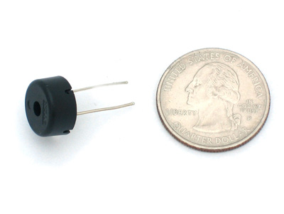

|  |  |
| --- | --- |
| **Supplier** | Adafruit: <http://www.adafruit.com/products/160> |
| **Online Tutorial & Example Code** | <http://learn.adafruit.com/adafruit-arduino-lesson-10-making-sounds> |
| **Tips and Tricks:**  This buzzer can produce a wide range of tones, but can’t play complicated songs like a full-size speaker would. Think, “Mary Had a Little Lamb.”  The tutorial will walk you through wiring this up and will also show you how to easily power this buzzer using the tone() and noTone() functions.  Click for more information on [tone()](http://arduino.cc/en/Reference/tone) and [noTone()](http://arduino.cc/en/Reference/NoTone).  Unfortunately you can only use one buzzer at a time. It’s not possible to create harmonies.  This tutorial has a list of all the notes on a piano and it’s frequency, which can be used with the tone() function: <http://arduino.cc/en/Tutorial/Tone> | |

**Re****lay**

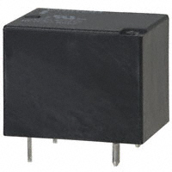

|  |  |
| --- | --- |
| **Supplier** | Digikey: <http://www.digikey.com/product-detail/en/G5LA-14%20DC5/Z2560-ND/1164329> |
| **Online Tutorial & Example Code** | None |
| **Tips and Tricks:**  Relays are electrically-controlled switches, similar to Transistors. Here’s a wiring diagram for our relays (bottom view of relay):  C:\Users\Michael\Documents\;ME 2900\08 SP 14\Labs\Arduino Lab 5-6 - Prototype\Datasheets\Actuators\Relay - Wiring Diagram.png  Setting the digital pin to HIGH will connect the “in” pin to either “out 1” or “out 2.” Setting the digital pin to LOW will connect the “in” pin to the other “out” one.  Because relays have physical moving components that contact each other, they can handle very large currents, much larger than most transistors. | |

**RGB** **LED**

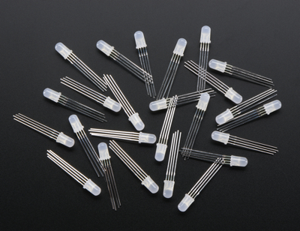

|  |  |
| --- | --- |
| **Supplier** | Adafruit: <http://www.adafruit.com/products/302> |
| **Online Tutorial & Example Code** | <http://learn.adafruit.com/adafruit-arduino-lesson-3-rgb-leds/overview> |
| **Tips and Tricks:**  These RGB LEDs can be used to generate any color you can imagine. There are four leads – the longest one connects to 5V through a resistor, and then the other three can be connected to ground (or digitalWrite(pin,LOW);) to turn on red, green, or blue. If you PWM the red, green, and blue pins, you can mix the colors to create any color you want!  Check out the tutorial for details. Note that these are **common-anode** LEDs, which means that the longest pin goes to 5V (not ground). Watch out for this in the tutorial. | |

**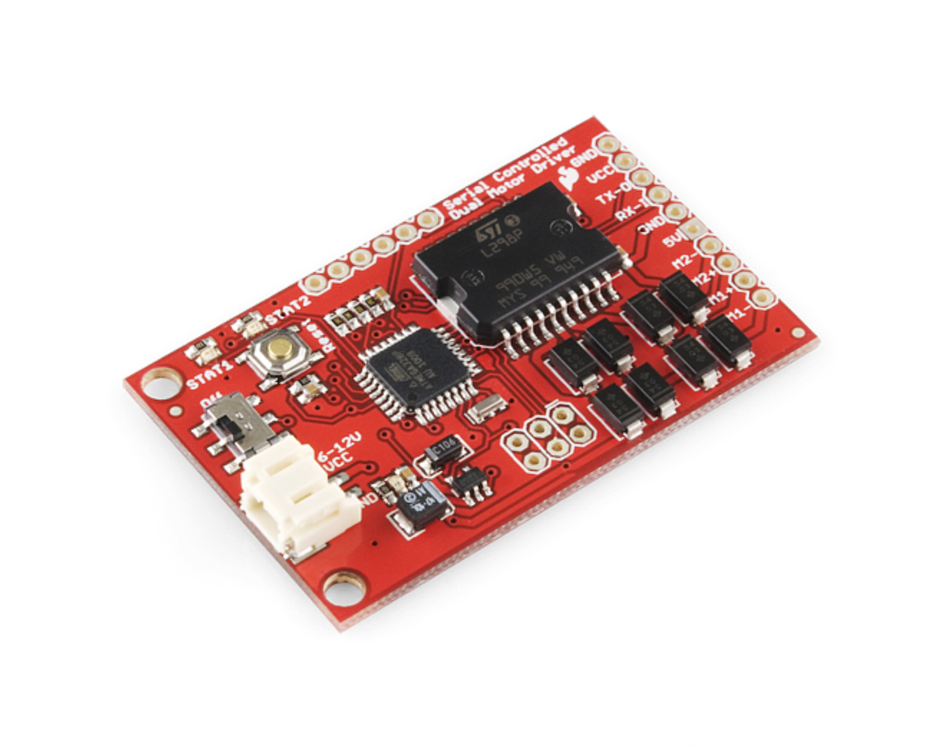Serial Cont****rolled Motor Driver**

|  |  |
| --- | --- |
| **Supplier** | Sparkfun: <https://www.sparkfun.com/products/9571> |
| **Online Tutorial & Example Code** | <https://www.sparkfun.com/datasheets/Robotics/SFE03-0012-UserGuide-ROB-09571-serialmotordriver.pdf> |
| **Tips and Tricks:** | |

**Simple Motor and Encoder Kit**

****

|  |  |
| --- | --- |
| **Supplier** | Dagu: <https://abra-electronics.com/robotics-embedded-electronics/robot-kits-en/rs034-hobby-motor-and-encoder-kit.html?sl=en> |
| **Online Tutorial & Example Code** | <https://learn.sparkfun.com/tutorials/redbot-assembly-guide-rev-02/all> |
| **Tips and Tricks:** | |

**So****lenoid**

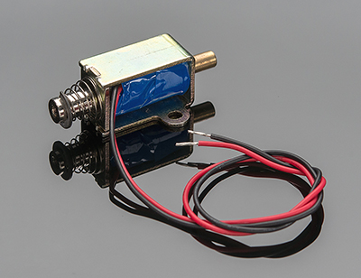

|  |  |
| --- | --- |
| **Supplier** | Adafruit: <http://www.adafruit.com/products/412> |
| **Online Tutorial & Example Code** | None |
| **Tips and Tricks:**  Solenoids are basically electromagnets: They are made of a big coil of wire with an armature (a metal rod) in the middle. When the coil is energized, the rod is pulled into the center of the coil. This makes the solenoid able to pull (from one end) or push (from the other).  This solenoid in particular is fairly small, with a 30mm long body and a 'captive' armature with a return spring. This means that when activated with up to 24VDC, the solenoid moves and then the voltage is removed it springs back to the original position, which is quite handy. Many lower cost solenoids are only push type or only pull type and may not have a captive armature (it'll fall out!) or don't have a return spring.  This requires a large amount of current (about 100 mA) to actuate, so don’t try to power it with a 9V battery (you’ll drain it fast). Use a 12V power supply and follow the wiring diagram from Lab 2. | |

**Stepper Motor (w****ith EasyDriver)**

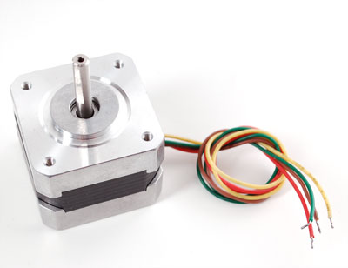 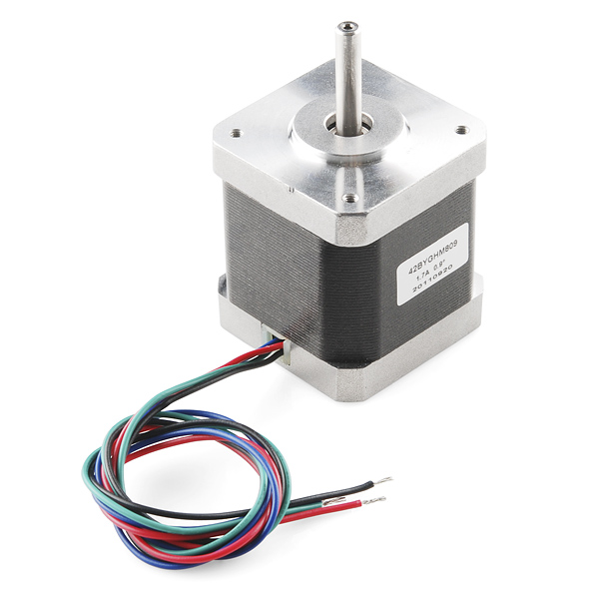 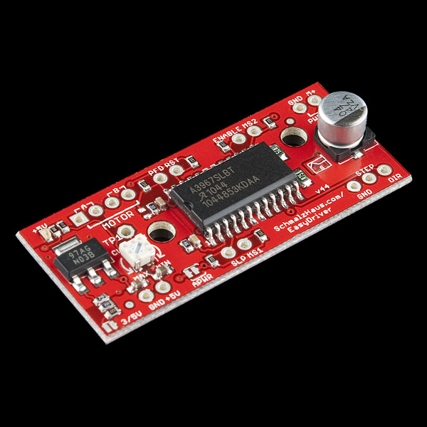

|  |  |
| --- | --- |
| **Supplier** | Adafruit, 200 steps/rev stepper motor: <http://www.adafruit.com/products/324>  SparkFun, 400 steps/rev stepper motor: <https://www.sparkfun.com/products/10846>  SparkFun, EasyDriver Stepper Motor Driver Board: <https://www.sparkfun.com/products/10267> |
| **Online Tutorial & Example Code** | <http://bildr.org/2011/06/easydriver/> |
| **Tips and Tricks:**  When you need lots of torque, precise speed, AND precise position, go with these stepper motors and use an EasyDriver to control them.  Both of these motors require 12V power to run, so you’ll also need to use an external power supply.  Connect 12V Power, Ground, and the Arduino to the EasyDriver as shown in the tutorial. Then, connect the motors to the EasyDriver’s four “motor” ports.  If you are using the 200 steps/rev motor from Adafruit, connect the wires in this order: red, yellow on “A” and green, gray on “B.”  If you are using the 400 steps/rev motor from SparkFun, connect the wires in this order: red, blue on “A” and black, green on “B.”  Then, run the example code from the tutorial. In the code, you’ll have to specify how many steps per revolutions your motor has. | |

**Stepper** **Motor (with H-Bridge)**

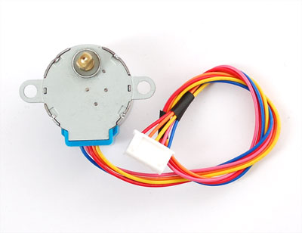

|  |  |
| --- | --- |
| **Supplier** | Adafruit: <https://www.adafruit.com/product/858> |
| **Online Tutorial & Example Code** | <http://learn.adafruit.com/adafruit-arduino-lesson-16-stepper-motors> |
| **Tips and Tricks:**  This stepper motor is a great way to get rotation with precise speed and position.  Inside this motor is a stepper motor with 32 steps per revolution, plus a gear train that has a 1/16.032 gear reduction. So, that turns this into a stepper motor with 513.024 steps per revolution!  This can be driven by an Arduino and an H-Bridge by following the tutorial. It runs at 5V power, so an external power supply is not needed. The maximum speed is about 25 RPM.  If you need more torque or a higher RPM, then use one of our other bigger stepper motors with the EasyDriver, detailed on the next page. | |

**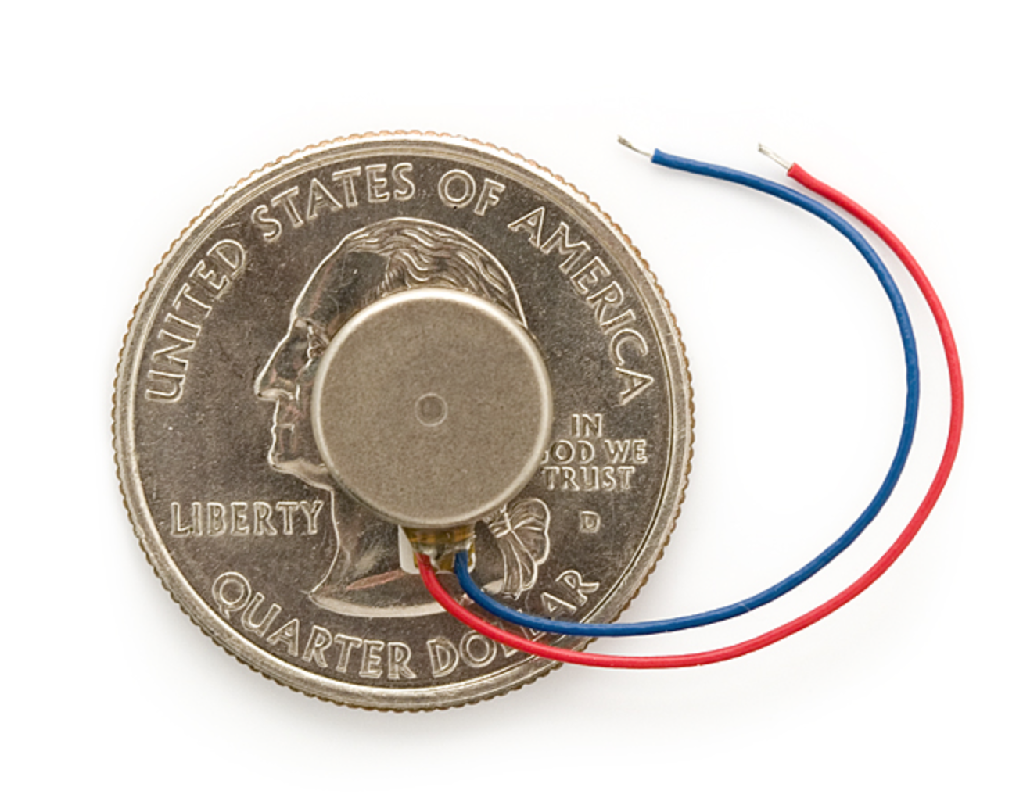Vibra****tion Motor**

|  |  |
| --- | --- |
| **Supplier** | Sparkfun: <https://www.sparkfun.com/products/8449>  Precision Microdrives: <http://www.precisionmicrodrives.com/vibrating-vibrator-vibration-motors/pancake-shaftless-coin-vibration-motors> |
| **Online Tutorial & Example Code** |  |
| **Tips and Tricks:** | |